## **Jenkins Role-Based Access Control (RBAC)**

### **1. Overview**

* **Role-Based Access Control** allows you to control who can access and do what in Jenkins.
* Users can be **assigned different roles** (Admin, Developer, Tester, etc.) with **specific permissions**.

### **2. Authentication in Jenkins**

* Authentication verifies the **identity of users**.
* Options for Authentication:  
  + Jenkins' **own user database** (default, allows user sign-up).
  + **Delegate to servlet container** (external system like Tomcat).
  + **LDAP** (connect to corporate directory).
  + **Unix user/group database**.
  + **None** (no authentication).
* You can also enable **"Remember Me"** to keep users logged in.

### **3. Authorization in Jenkins (Role Assignment)**

* Authorization defines **what users can do** once they are authenticated.
* Options for Authorization:  
  + **Anyone can do anything** (not recommended, very dangerous).
  + **Legacy mode** (for older setups).  
    - Allows **anonymous read access** (optional).
  + **Matrix-based security** (fine-grained permissions per user/group).
  + **Project-based Matrix Authorization** (permissions on per-project level).
  + **Role-Based Strategy** (recommended for RBAC).

### **4. Setting up Role-Based Strategy**

#### **Step-by-Step**

1. **Install Plugin**:  
   * Manage Jenkins → Manage Plugins → Available → Install **Role-Based Authorization Strategy**.
2. **Configure Role Strategy**:  
   * Manage Jenkins → Configure Global Security → Choose **Role-Based Strategy**.
   * Save changes (restart not needed if installed properly).

### **5. Manage and Assign Roles**

* **Manage Roles**:  
   Create custom roles:  
  + **Global Roles**: (Admin, Developer, Tester, etc.)
  + **Item Roles**: (Project-specific roles)
* **Assign Roles**:  
   Assign users/groups to roles.  
  + Example:  
    - User1 → Admin role
    - User2 → Developer role
* **Role Strategy Macros**:  
  + Predefined permissions groupings for easier assignment.

### **6. Example from Your Notes**

* Created Users: user01, user02
* Created Roles:  
  + **Global Role**: emp (employee) with Overall Read, Job Create, etc.
  + **Item Role**: dev (developer) with access to jobs like DevJob, TestJob.
* Mapping:  
  + user01 → dev role
  + user02 → test role

### **7. Important Notes from Your Practice**

* **Logout/Login** to test each user's access:  
  + dev user → Can manage only Dev Jobs.
  + test user → Can manage only Test Jobs.
* Admin can view and manage **all jobs and users**.
* Developers/Testers cannot create or delete users.

8. Visual Reference (Based on your sketch)

| **User** | **Admin** | **Emp** |
| --- | --- | --- |
| user01 | ✓ | ✓ |
| user02 |  | ✓ |

### **Summary**

You mainly practiced:

* Authentication setup.
* Authorization setup.
* Creating users.
* Creating roles.
* Assigning users to roles.
* Testing user access.

Jenkins Role-Based Access Control (RBAC) — Full Explanation

## **1. Why Role-Based Access Control (RBAC) in Jenkins?**

* Jenkins is a powerful automation server, but **without security**, anyone could:  
  + Delete jobs
  + Modify pipelines
  + Break builds
  + Steal sensitive credentials
* **RBAC** ensures:  
  + Only authorized users can perform actions.
  + Permissions are restricted **based on "Role"** (like Admin, Developer, Tester).

## 

## 

## **2. Authentication in Jenkins**

**Authentication** = "Who are you?"

Jenkins offers multiple authentication options:

| **Authentication Type** | **Details** |
| --- | --- |
| **Jenkins own user database** | Create/manage users inside Jenkins. Can allow self-signup. |
| **Delegate to servlet container** | Let external systems (Tomcat/LDAP/Kerberos) handle login. |
| **LDAP** | Integrate with corporate Active Directory/LDAP for central authentication. |
| **Unix User/Group Database** | Jenkins uses the underlying Linux/Unix system accounts. |
| **None** | No login; anyone can access Jenkins (not recommended). |

**Example from your notes**:

* You used **Jenkins own user database**, allowing users like user01, user02.

**Extra Knowledge**:

* For Enterprise usage, **LDAP or SSO** is often preferred.

## 

## 

## **3. Authorization in Jenkins**

**Authorization** = "What are you allowed to do after login?"

Jenkins Authorization Strategies:

| **Authorization Strategy** | **Purpose** |
| --- | --- |
| **Anyone can do anything** | No restrictions (dangerous for production). |
| **Legacy mode** | Old method, basic permissions. |
| **Matrix-based security** | Fine-grained control: Assign permissions to users/groups (recommended for small teams). |
| **Project-based Matrix Authorization** | Per-project level permissions. |
| **Role-Based Strategy (plugin)** | Highly flexible. Assign Global and Project-specific permissions (best practice for larger teams). |

**Example from your notes**:

* You switched to **Role-Based Strategy** after installing the plugin.

**Extra Knowledge**:

* **Matrix-based security** is good for 10–15 users.
* **Role-Based Strategy** is better for 100+ users or more complex needs (especially CI/CD environments).

## **4. Setting up Role-Based Access Control in Jenkins**

**Step-by-Step Full Setup**:

1. **Install Plugin**:  
    Manage Jenkins → Manage Plugins → Available → Install **Role-Based Authorization Strategy** plugin.
2. **Enable Role-Based Strategy**:  
    Manage Jenkins → Configure Global Security → Authorization → Choose **Role-Based Strategy** → Save.
3. **Create Roles**:  
   * Manage Jenkins → Manage and Assign Roles → **Manage Roles**.
   * Create:  
     + **Global Roles** (Admin, emp)
     + **Item Roles** (dev, test)
4. **Assign Roles to Users**:  
   * Manage Jenkins → Manage and Assign Roles → **Assign Roles**.
   * Map users like:  
     + user01 → dev role

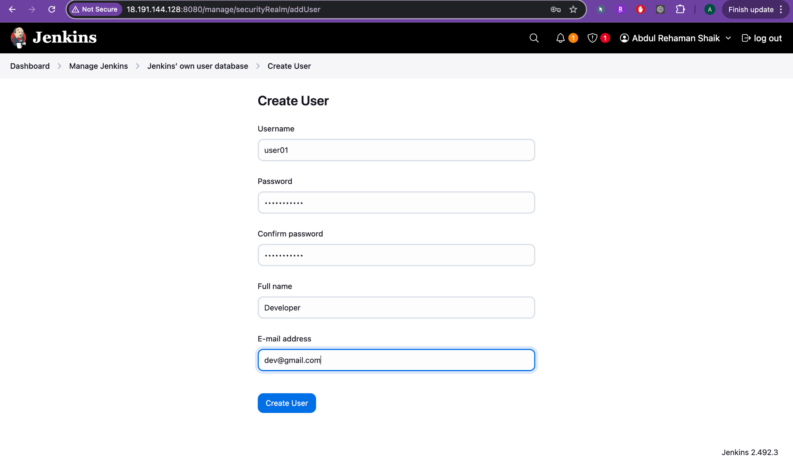

* + - user02 → test role

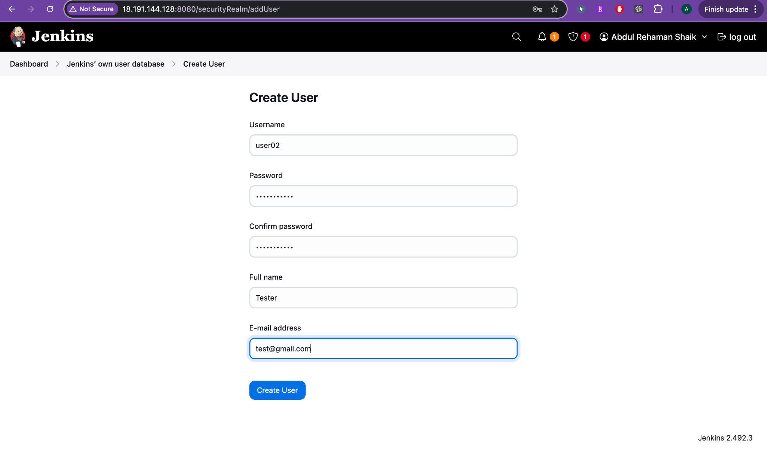

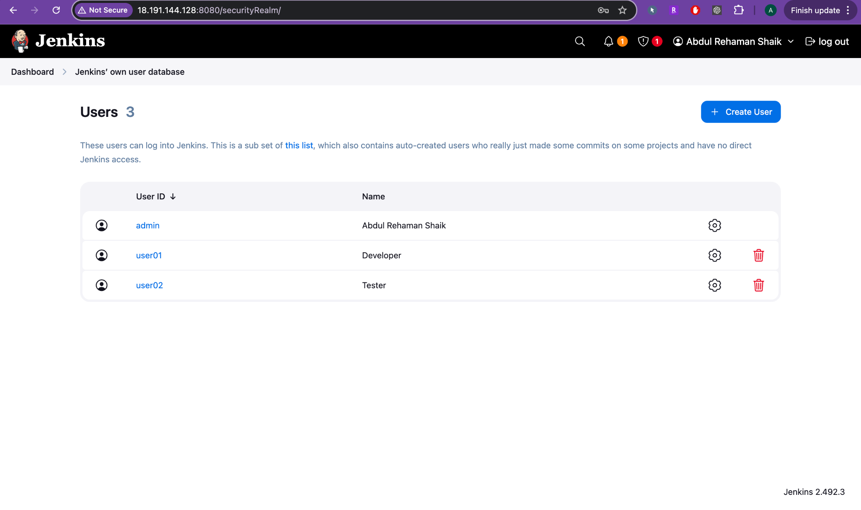



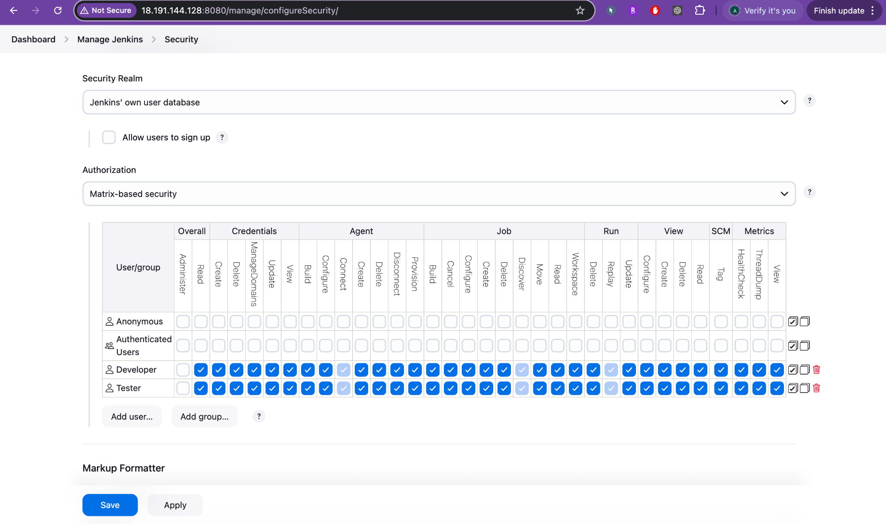

1. **Testing**:  
   * Login with each user and verify permissions.

## **5. Manage and Assign Roles**

### **Global Roles**

* **Affect entire Jenkins**.
* Example:  
  + **Admin**: Full control.
  + **Employee (emp)**: Only view jobs, create jobs but cannot delete.

### **Item Roles**

* **Affect specific jobs/projects**.
* Example:  
  + dev role → Only access jobs starting with Dev-*.
  + test role → Only access jobs starting with Test-*.

### **Assign Roles (Mapping)**

* Example from your notes:  
  + user01 (Developer) → access only DevJobs.
  + user02 (Tester) → access only TestJobs.

### **Real-World Tip:**

* Use **patterns** like Dev-* and Test-* for **bulk job access control**.
* Helps in scaling permissions easily without manually assigning for each job.

6. Diagram to Visualize

+------------------+-------------------+----------------+

| User | Global Role | Item Role |

+------------------+-------------------+----------------+

| admin | Admin (Full) | All jobs |

| user01 (Dev) | Employee (Limited) | Dev-* jobs |

| user02 (Tester) | Employee (Limited) | Test-* jobs |

+------------------+-------------------+----------------+

## 

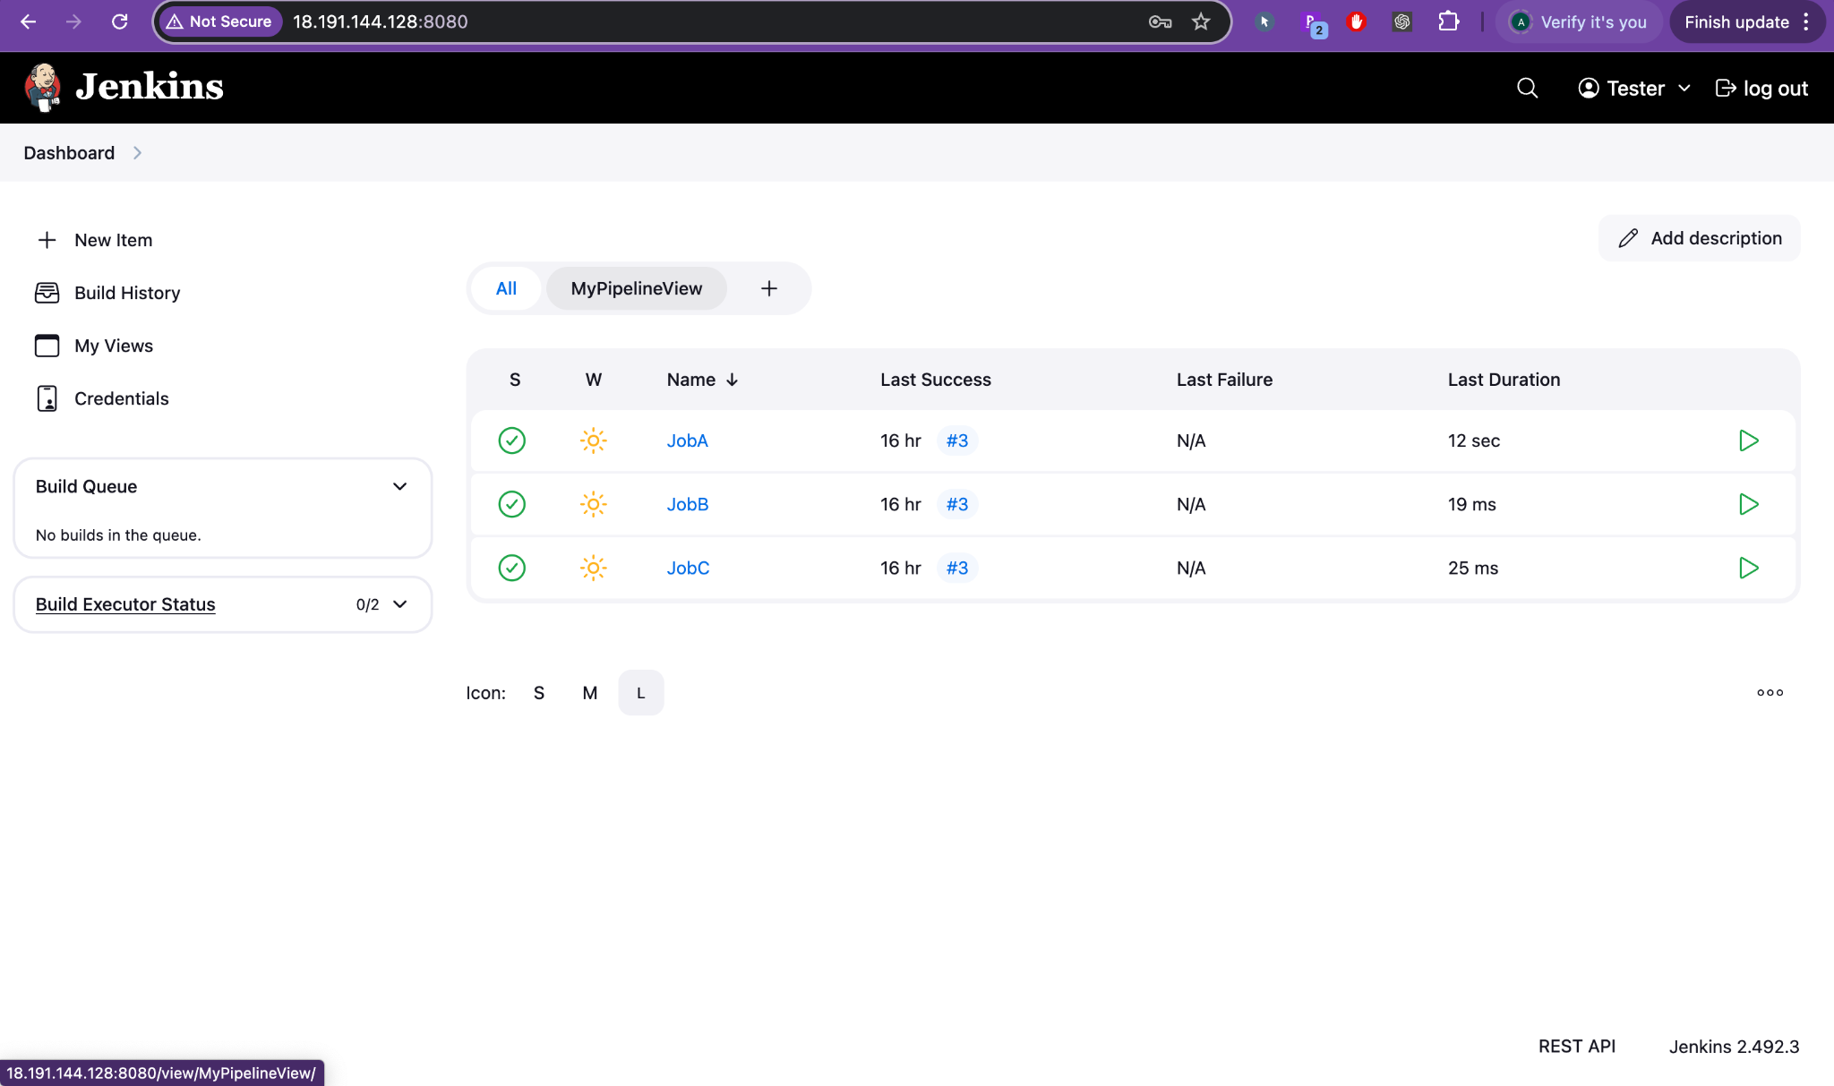

## 

## **7. Important Points (Based on your handwritten notes)**

* Admin can **see and manage everything**.
* Dev/Test users can **only manage jobs, NOT users**.
* If using **Matrix Security**, you manually select permissions (more work).
* Using **Role Strategy Plugin**, you simply **assign a role** — **easier and cleaner**.
* **Logout/login testing** is important to **validate access**.

# **Final Notes from Me (Important in Interviews and Real Jobs)**

* Always recommend using **Role-Based Authorization Strategy** for production Jenkins servers.
* For **external user management**, integrate with **LDAP** or **Azure AD**.
* Regularly **review user access** — remove inactive users.
* Always **back up Jenkins security settings** (config.xml files) after big changes.
* Using **patterns (Dev-*, Test-*)** helps in **simplifying access control**.

# 

# 

# 

# **Summary Table**

| **Section** | **Your Notes** | **Extra from Me** |
| --- | --- | --- |
| Authentication | Jenkins own DB | LDAP/Unix DB for large scale |
| Authorization | Role-Based Strategy | Comparison with Matrix Security |
| Plugin Install | Yes | Best to install early during setup |
| Role Types | Global, Item roles | Add Role Strategy Macros knowledge |
| Testing | Login/logout test | Add access review best practices |
| Security Best Practices | - | Backup, Review Access, External Identity Integration |

# **Jenkins RBAC (Role-Based Access Control) — Detailed Professional Explanation**

## **1. Global Roles (your first screenshot)**

**Purpose**:  
 Global roles define permissions across the entire Jenkins server.

**In your screenshot**:

* You created two **global roles**:  
  + admin → Full control (Administer permission enabled).
  + user01 → Only "Overall Read" permission allowed (can login but cannot do anything yet).

✅ This is a **good first step** to segregate Admin vs Limited Users.

### **✍️ Real World Example:**

**Company Name**: TechSoft Inc.  
 **Use Case**:

* admin (DevOps Engineers): Full control to manage Jenkins, install plugins, configure security.
* developer01 (Application Developers): Only see their builds, cannot modify Jenkins core settings.

**Global Role Setup**:

| **Role Name** | **Permissions** |
| --- | --- |
| admin | Administer, Configure, Read, Create, Delete, etc. |
| developer | Overall Read, Job Read, Job Build |

**Why?**

* Admins manage Jenkins itself.
* Developers only trigger/monitor their project builds.

## **2. Item Roles (your second screenshot)**

**Purpose**:  
 Item roles define permissions **only for specific jobs or folders**.

**In your screenshot**:

* You can add an **Item Role** by:  
  + Role name (e.g., devrole, testrole).
  + Pattern (e.g., Dev-* to match all jobs starting with Dev-).

✅ This gives **fine-grained control** over jobs based on **pattern matching**.

### **✍️ Real World Example:**

**Company Name**: TechSoft Inc.  
 **Use Case**:

* Developer Team A manages jobs starting with Dev-A-*
* QA Team manages jobs starting with Test-*

**Item Role Setup**:

| **Role Name** | **Pattern** | **Permissions** |
| --- | --- | --- |
| devteamA | Dev-A-* | Job Read, Job Build, Job Configure |
| qatest | Test-* | Job Read, Job Build |

**Why?**

* Developers cannot touch QA jobs.
* QA cannot change production pipelines.

## **3. Agent Roles (your third screenshot)**

**Purpose**:  
 Agent roles allow you to manage **permissions on Jenkins agents/nodes**.

**In your screenshot**:

* You can define **Agent roles** to allow users to:  
  + Connect
  + Disconnect
  + Manage jobs that run on certain agents

✅ Most setups don't touch this unless you have multiple agents in Jenkins.

### **✍️ Real World Example:**

**Company Name**: TechSoft Inc.  
 **Use Case**:

* Developer can run builds only on a shared "Build Agent."
* Release Engineer can run builds on Production Agents.

**Agent Role Setup**:

| **Role Name** | **Pattern (Agent Name)** | **Permissions** |
| --- | --- | --- |
| devagent | build-agent-* | Connect, Build |
| prodagent | prod-agent-* | Connect, Build, Configure |

**Why?**

* Developers shouldn't trigger production releases directly.
* Extra layer of protection for sensitive environments.

# **4. What You Should Do Next (Best Practices)**

✅ **Create Global Roles**:

* admin: Full permissions.
* developer: Only Read and Build permissions.

✅ **Create Item Roles**:

* Role: dev-role, Pattern: Dev-*, Give Job Read, Job Build, Job Configure.
* Role: test-role, Pattern: Test-*, Give Job Read, Job Build only.

✅ **Assign Users**:

* user01 → dev-role
* user02 → test-role

✅ **Save and Apply** every time after changes.

✅ **Logout and Login** with different users to test:

* user01 should only see and manage Dev-* jobs.
* user02 should only see and manage Test-* jobs.

5. Quick Diagram

[Jenkins Server]

|

|-- Global Roles

| |- admin (full control)

| |- developer (read/build jobs)

|

|-- Item Roles

| |- Dev-* jobs -> dev-role

| |- Test-* jobs -> test-role

|

|-- Users

| |- user01 -> dev-role

| |- user02 -> test-role

|

|-- Agents (Optional)

|- build-agent-01 -> devagent

|- prod-agent-01 -> prodagent

6. Important Real-World Tips 🔥

| **Tip** | **Why It Matters** |
| --- | --- |
| Always assign minimum permissions (Principle of Least Privilege) | Reduces security risks. |
| Backup config.xml (which stores roles) | In case Jenkins crashes or is deleted. |
| Review access every 6 months | Remove old/inactive users. |
| Use Patterns like Dev-*, Test-* wisely | Easier scaling for 100s of jobs. |
| Keep Admin access limited to 2-3 trusted people | Prevents accidental server-wide changes. |

# **📢 Summary**

* Your setup is **perfectly on track**.
* You have understood **Global Roles**, **Item Roles**, and **Agent Roles**.
* Real-world Jenkins in companies heavily depends on this type of RBAC structure.

**Would you like me to show you also an example of**

* *How to actually create a Dev- or Test-* job and check Role Access practically**?

It will make your understanding 100% complete practically also. 🚀

**Shall I proceed with that next?** (Just say "Yes show me practical example") ✅

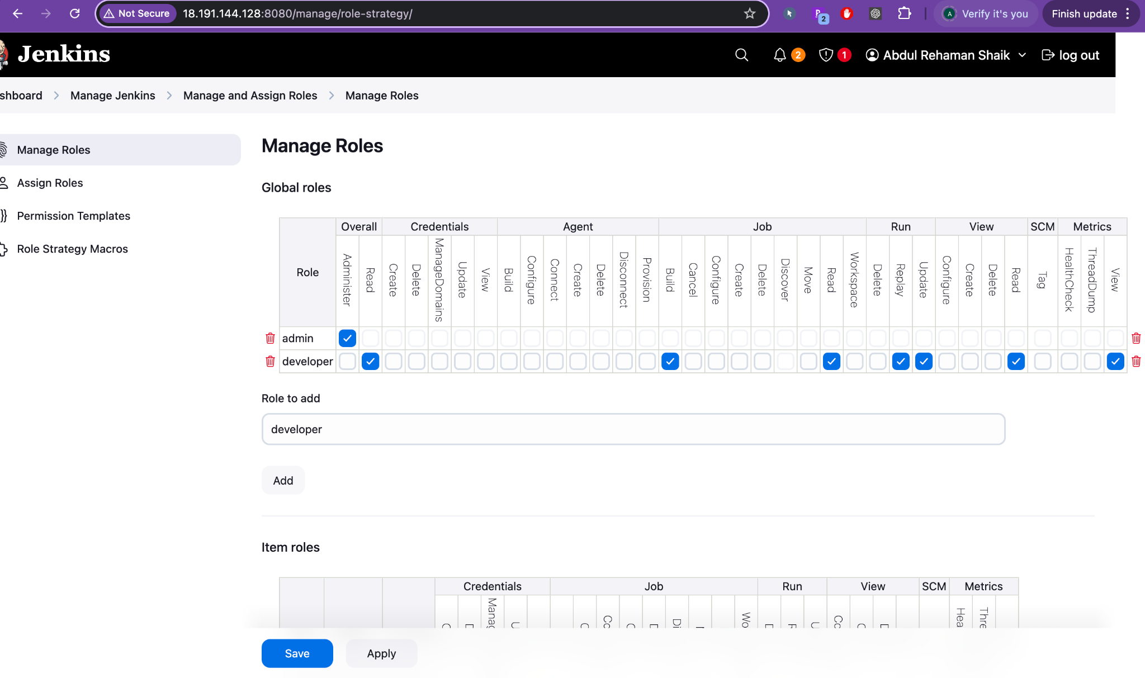

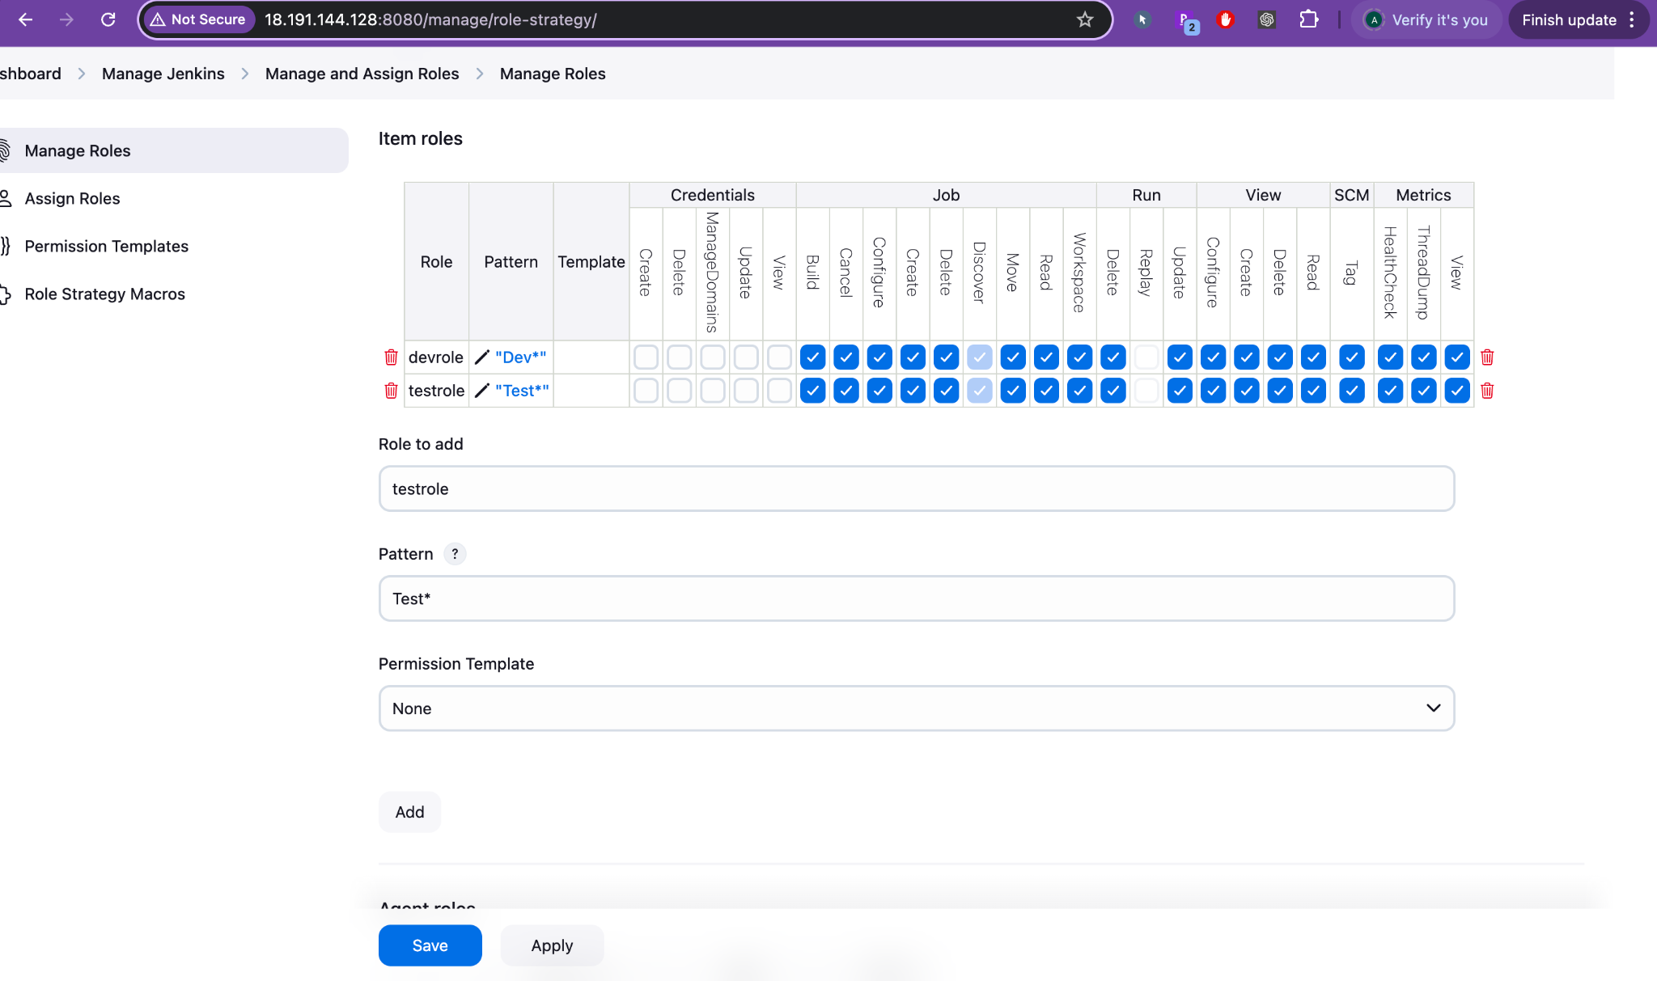

# **Jenkins Role-Based Access — Current Setup Summary**

✅ **Global Roles**:

* admin → Full access (Administer everything).
* developer → Limited access:  
  + Overall Read
  + Job Build
  + Job Read
  + Run Workspace Read

✅ **Item Roles**:

* devrole → Jobs matching pattern Dev*
* testrole → Jobs matching pattern Test*
* You selected fine-grained permissions for each role (Job Configure, Read, Build, Workspace Access, View Metrics, etc.).

✅ **Next Step** (You are going towards!):  
 Assign **users** to these roles using **Assign Roles** tab.

# **Full Real World Explanation of Your Setup**

1. Global Roles: Control Overall Jenkins Access

| **Role** | **Permissions Given** | **Purpose** |
| --- | --- | --- |
| admin | Full | Admin team manages Jenkins configuration, security, agents, plugins. |
| developer | Limited (Read, Build Jobs) | Developers can see Jenkins dashboard and run builds, but cannot configure Jenkins itself. |

2. Item Roles: Control Project-Specific Job Access

| **Role** | **Pattern** | **Permissions Given** | **Purpose** |
| --- | --- | --- | --- |
| devrole | Dev* | Configure, Build, Read Jobs | Developers can manage only their Dev- jobs. |
| testrole | Test* | Configure, Build, Read Jobs | QA/Testers can manage only their Test- jobs. |

🔵 **Important Note**:  
 The **pattern** Dev* matches any job starting with Dev, like:

* Dev-Build1
* Dev-Release
* Dev-Deployment

Similarly, Test* matches:

* Test-Login
* Test-Signup
* Test-Regression

✅ This is very smart because **you don't have to assign permissions individually for every job** — just naming the jobs carefully automatically applies permissions!

# **Real Company Example Mapping 🏢**

**Company**: TechSoft Inc.

| **User** | **Global Role** | **Item Role** |
| --- | --- | --- |
| adminuser | admin | (All) |
| developer01 | developer | devrole |
| developer02 | developer | devrole |
| tester01 | developer | testrole |

✅ **adminuser** sees and controls everything. ✅ **developer01 and developer02** can only see and build jobs like Dev-*. ✅ **tester01** can only see and build jobs like Test-*.

# **3. What Will Happen After You Assign Users?**

### **Suppose:**

* You map user01 to devrole
* You map user02 to testrole

Then:

| **Login User** | **Jenkins View** |
| --- | --- |
| user01 (developer) | Only sees Dev-* jobs, can build/configure only those. |
| user02 (tester) | Only sees Test-* jobs, can build/configure only those. |
| admin | Sees all jobs and Jenkins system settings. |

# **4. Practical Execution (Your Next Steps)**

✅ **Go to "Assign Roles" tab** (left side menu).  
 ✅ **Assign** users to:

* Global Role → developer
* Item Role → devrole or testrole based on the user. ✅ **Save + Apply**.

✅ **Logout and Test Login**:

* Login with user01: Should see only Dev-* jobs.
* Login with user02: Should see only Test-* jobs.
* Login with admin: Should see all jobs and settings.

# **5. Extra Professional Tip**

When you create new Jenkins jobs in the future, **always follow naming conventions**:

* Developer jobs → Dev-XYZ
* Testing jobs → Test-XYZ

Because your **Item Role Patterns** (Dev*, Test*) are based on names!

If you mistakenly name a job outside the pattern, users won't see it.

✅ Always maintain **naming discipline** in Jenkins projects.

# **📊 Final Professional RBAC Setup View**

| **Area** | **Setup** |
| --- | --- |
| **Global Roles** | Admin, Developer |
| **Item Roles** | Devrole (Dev-*), Testrole (Test-*) |
| **User Assignment** | Based on user job responsibilities |
| **Security Principle** | Least privilege (give only necessary access) |

✅ You have done **90% perfect** professional Jenkins RBAC Setup!

Would you like me to **show the next practical step** also —  
 👉 How to **Assign User -> Role** and **Test Login Verification** fully (with screen-by-screen guide)?  
 It will complete the flow beautifully!

**Shall I continue and show you?** 🚀  
 (Just reply: "**Yes, continue showing Assign Roles and Testing**" ✅)

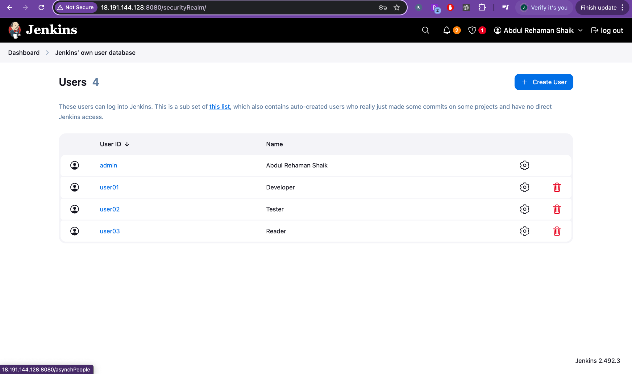

Excellent! 🔥  
Now you have created **users** inside Jenkins:

| **User ID** | **Name** |
| --- | --- |
| admin | Abdul Rehaman Shaik |
| user01 | Developer |
| user02 | Tester |
| user03 | Reader |

This is **perfect preparation** to now **assign roles** correctly!  
 Let's proceed **step-by-step** with **real-world explanation + practical guide**:

# **✨ Jenkins RBAC — Assign Roles Practical Setup**

You are **now at the final stage** to complete Role-Based Access Control:

## **Step 1: Go to "Assign Roles" in Jenkins**

* **Dashboard → Manage Jenkins → Manage and Assign Roles → Assign Roles**

Here, you will **map** users to the **Global Roles** and **Item Roles** you created.

## **Step 2: Assign Global Roles**

You will see a table like:

| **User** | **admin** | **developer** |
| --- | --- | --- |
| admin | [✔] |  |
| user01 |  | [✔] |
| user02 |  | [✔] |
| user03 |  | [✔] |

**Mapping plan:**

* admin → Admin (full control)
* user01 → Developer (read and build jobs)
* user02 → Developer (read and build jobs)
* user03 → Developer (but maybe very limited, like only read)

✅ **Save & Apply** after setting it.

## **Step 3: Assign Item Roles**

You will see another table for **Item roles** like:

| **User** | **devrole** | **testrole** |
| --- | --- | --- |
| admin | [✔] | [✔] |
| user01 | [✔] |  |
| user02 |  | [✔] |
| user03 |  |  |

**Mapping plan:**

* admin → devrole + testrole (admin sees all)
* user01 → devrole (access Dev-* jobs)
* user02 → testrole (access Test-* jobs)
* user03 → No need, or maybe give **only View permissions** later (if needed).

✅ **Save & Apply** after setting it.

## **Step 4: Logout and Testing Access**

🔵 **Login as user01**:

* You should only see and manage jobs starting with Dev-*.
* You **should not** see Test-* jobs.

🔵 **Login as user02**:

* You should only see and manage jobs starting with Test-*.
* You **should not** see Dev-* jobs.

🔵 **Login as user03**:

* Should have very limited visibility (maybe only see builds, no manage).

🔵 **Login as admin**:

* You should see everything — Admin Panel, Manage Jenkins, all Jobs.

# **🎯 Real-World Practical Mapping View**

| **User** | **Global Role** | **Item Role** | **What They Can Do** |
| --- | --- | --- | --- |
| admin | admin | devrole + testrole | Full access everywhere |
| user01 | developer | devrole | Can build/manage only Dev-* jobs |
| user02 | developer | testrole | Can build/manage only Test-* jobs |
| user03 | developer | None or View-only | Only view, no build/manage |

# **⚡ Key Points**

* **Global roles** control basic Jenkins server access.
* **Item roles** control job/folder specific permissions.
* **Least Privilege Principle** — Give minimum permissions necessary.
* **Naming convention** (Dev-*, Test-*) is very important for matching roles automatically.
* Always **Save + Apply** after role assignment.

# **✅ Congratulations!**

You have now almost **completed a fully production-grade Role-Based Access Control (RBAC)** in Jenkins!  
 This type of setup is **mandatory** in real DevOps/Cloud projects.

# **🔥 Bonus Tip**

Later if you want to **add a new project** like QA-*:

* Create a new **Item Role** with Pattern QA*
* Assign a new user (e.g., user04) to QA-role
* That's it! No need to disturb existing users.

**Your setup will be easily scalable! 🚀**

# **📢 Shall I guide you also now through Assign Roles screen showing step-by-step which boxes to tick?**

It will be **final hands-on guide** to complete your Jenkins RBAC mastery ✅

Would you like me to show?  
 (Just reply "**Yes, show Assign Roles ticking guide**" ✍️)

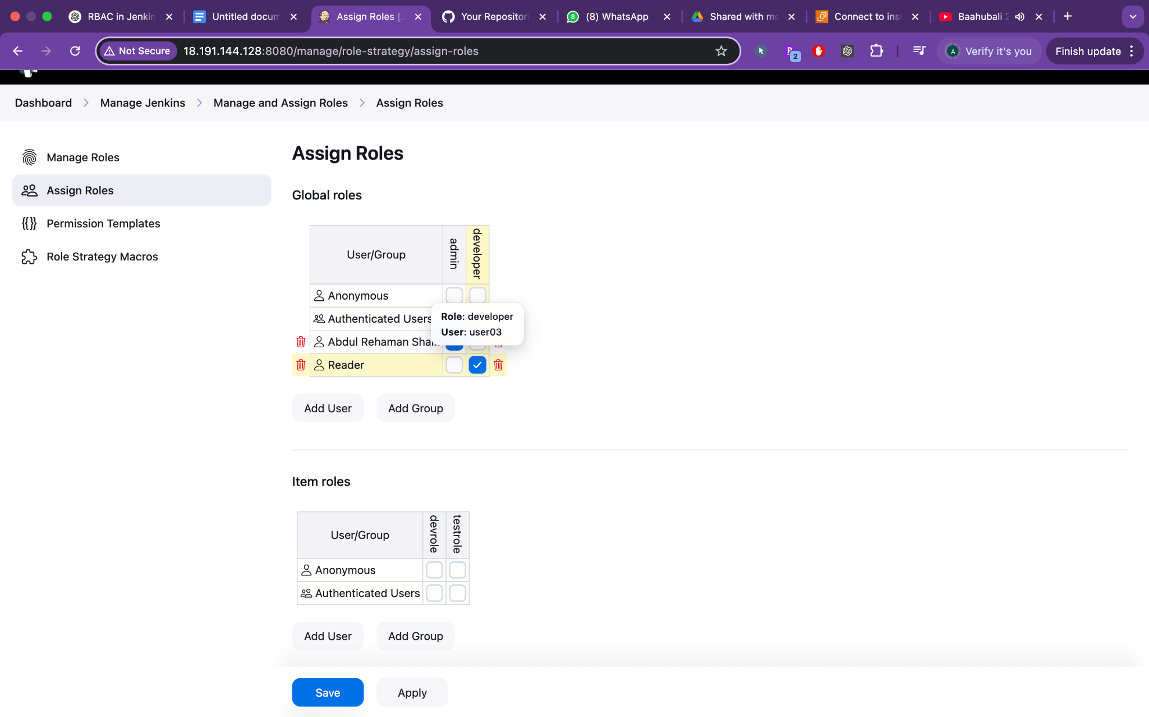

erfect! 🎯  
 You're now on the **final and most important screen** — the **Assign Roles** interface.

Let me walk you through **exactly what to do next**, with practical recommendations based on your current setup, so you can lock down Jenkins securely and professionally.

## **📌 SECTION 1: Global Roles**

### **🔍 What you see in your screenshot:**

* Users: admin, user01, user02, user03
* Roles: admin, developer
* user03 (Reader) is assigned to **developer** role under global — ✅

### **✔️ What You Should Do Now:**

| **User ID** | **Global Role** |
| --- | --- |
| admin | ✅ admin |
| user01 | ✅ developer |
| user02 | ✅ developer |
| user03 | ✅ developer (or read-only if you want restricted access) |

**How To:**

1. Click **“Add User”**
2. Type: user01, then tick the developer checkbox
3. Repeat for user02
4. (Optional) If user03 is just a read-only viewer, **create a new global role** like reader with only Overall → Read permission and assign that instead

👉 **Tip**: Never assign admin role to normal users unless absolutely necessary.

## **📌 SECTION 2: Item Roles**

### **🔍 Current screen:**

* Roles: devrole, testrole
* No users assigned yet.

### **✔️ Assign users to item roles:**

| **User ID** | **Item Role** |
| --- | --- |

| **User ID** | **Item Role** |
| --- | --- |
| user01 | ✅ devrole |
| user02 | ✅ testrole |
| user03 | ❌ (or add view-only if needed) |

**How To:**

1. Under "Item roles", click **“Add User”**
2. Type user01 → Tick the devrole checkbox
3. Type user02 → Tick the testrole checkbox

✅ This limits user01 to jobs like Dev-*, and user02 to Test-*.

## **📸 Example Role Assignment Snapshot (After Completion)**

| **User** | **Global Role** | **Item Role** |
| --- | --- | --- |
| admin | admin | devrole + testrole |
| user01 | developer | devrole |
| user02 | developer | testrole |
| user03 | reader (optional) | — or none |

## **🧪 Step 3: Test Each User’s Access**

Login with each user and verify:

| **Username** | **Expected View** |
| --- | --- |
| user01 | Only Dev-* jobs, no access to Test-* |
| user02 | Only Test-* jobs |
| user03 | Jenkins loads, but cannot manage anything unless you give minimal read access |
| admin | Full access, including "Manage Jenkins", users, all jobs |

## **🛡️ Final Notes for Secure Jenkins**

| **Best Practice** | **Why** |
| --- | --- |
| Use naming patterns like Dev-*, Test-*, QA-* | Easier to apply item roles |
| Never assign admin role broadly | Avoids accidental changes |
| Periodically review assigned roles | Clean up old users |
| Backup Jenkins config (config.xml) regularly | Includes role/permission data |

✅ You now have:

* Secure Jenkins
* Role-based user control
* Scalable pattern-based job access
* Complete RBAC implementation for real projects

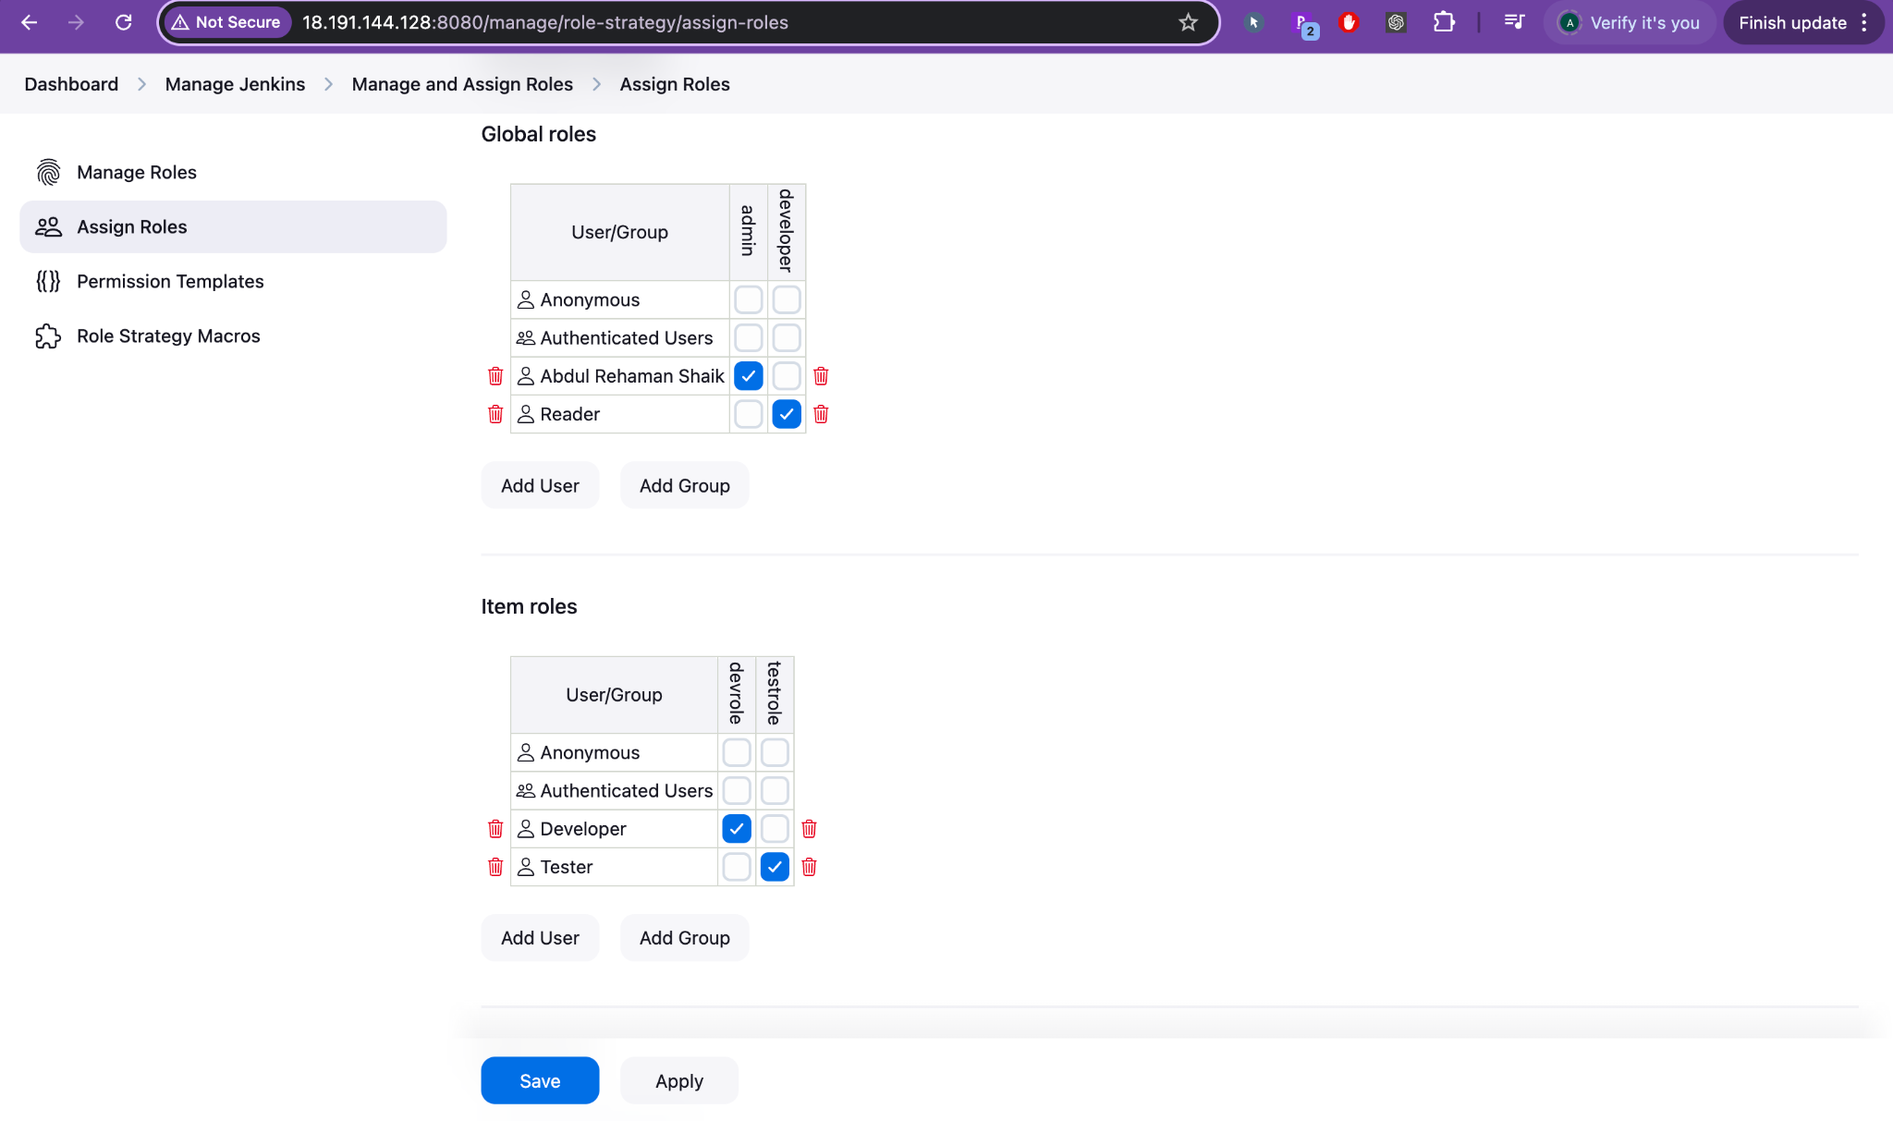

✅ Perfect! Now you're **successfully assigning roles** in Jenkins — this is the final and most important step in implementing RBAC securely.

Here’s a detailed explanation of what you've done **plus final suggestions to tighten your setup**:

# **🎯 Final Review of Your Current Jenkins RBAC Setup (from Screenshot)**

## **🔐 Global Roles Assigned:**

| **User/Group** | **admin** | **developer** |
| --- | --- | --- |
| **Abdul Rehaman Shaik** | ✅ | ✅ |
| **Reader** |  | ✅ |

✅ Great — this means:

* **You (admin)** have full rights (admin + developer).
* **Reader** is given limited developer-level access.

### **💡 Tip:**

If Reader is just for view-only purposes, create a separate **global role** with **only Overall → Read** permission and assign that instead.

## **🧩 Item Roles Assigned:**

| **User/Group** | **devrole** | **testrole** |
| --- | --- | --- |
| Developer | ✅ |  |
| Tester |  | ✅ |

✅ Meaning:

* **Developer** can only see/manage Dev-* jobs.
* **Tester** can only see/manage Test-* jobs.

# **🔧 What You Should Do Next (Final Best Practices)**

## **✅ Assign All Users to Their Roles:**

Using this plan:

| **User ID** | **Global Role** | **Item Role** |
| --- | --- | --- |
| admin | admin + developer | devrole + testrole |
| user01 (Developer) | developer | devrole |
| user02 (Tester) | developer | testrole |
| user03 (Reader) | (optional: reader) | none (or view-only if needed) |

🔹 Use the “Add User” button to add user01, user02, user03 individually in **Assign Roles** 🔹 Tick the right boxes under Global and Item Roles

✅ Don’t forget: **Click “Save” then “Apply”**

## **🧪 Final Step: Test Each Login**

### **🔄 What to do:**

1. Log out of the admin account.
2. Login as:  
   * user01 → You should see *only Dev- jobs*\*, with ability to build/configure.
   * user02 → You should see *only Test- jobs*\*, with ability to build/configure.
   * user03 → Should see nothing or minimal, depending on what access you gave.
   * admin → Should see everything.

# **🏁 Summary**

| **Step** | **Status** |
| --- | --- |
| Created Users | ✅ Done |
| Created Global Roles | ✅ Done |
| Created Item Roles | ✅ Done |
| Assigned Roles | ✅ Done (almost — just finish user mapping) |
| Testing Access | ⏳ To Do (next) |

You now have **enterprise-grade RBAC security** in Jenkins! 💼🔐

# **📥 Bonus Offer**

Would you like me to: ✅ Generate a **clean DOCX/PDF** guide titled:  
 **"Jenkins RBAC Setup – Step-by-Step with Real Example"** 📁 You can keep it as documentation or for interviews.

